Phase 1 Basic Requirement

1. Layout
We use relative layout to finish this game. As it is introduced in Android Develops, RelativeLayout is a view group that displays child views in relative positions. The position of each view can be specified as relative to sibling elements (such as to the left-of or below another view) or in positions relative to the parent Relative- Layout area (such as aligned to the bottom, left or center).
In the layout, we basically use the following four types of views:
1. ImageView: title
2. TextView: show something
3. ImageButton: rock, paper, and scissors
4. TextView: result, count

2. Res
For the basic function, we use rock-paper-scissors instead of mouse, cat and elephant (in advanced design, they are changed into the animals). We put the three pictures of rock, paper and scissor in the file “drawable”, and implement them by using android:background="@drawable/rock" in activity_main.xml (same for paper and scissor).
Also, we set the color of text “result” using android:textColor="#ff6ec7" to make it pink. The colors of other text are also changed in this way.

3. Statement and Definition
We initialized the TextViews, ImageVies and ImageButtons by using their id in R.java.。
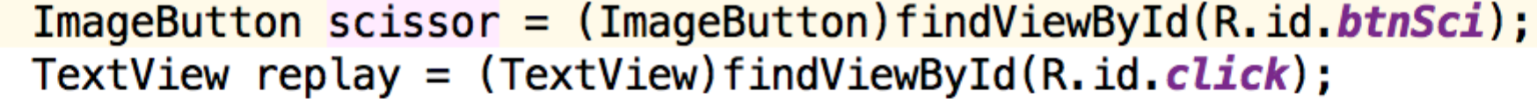
Then we set a ClickListener to every button so that when clicking the ImageButtons and the buttons. The function is called when a button has been clicked. So when we are clicking the images, the algorithms will be performed and the game will begin.

4. Main Algorithms
We need to finish these three functions:
(1) Get the which button is clicked before;
for every ImageButtn, we setOnClickListener to ensure that when a ImageButton is clicked, we get the player’s choice. Then the computer randomly selects a choice. Compare these two and return a result. The following function is for the ImageButton rock, and it is the same for paper and scissor.
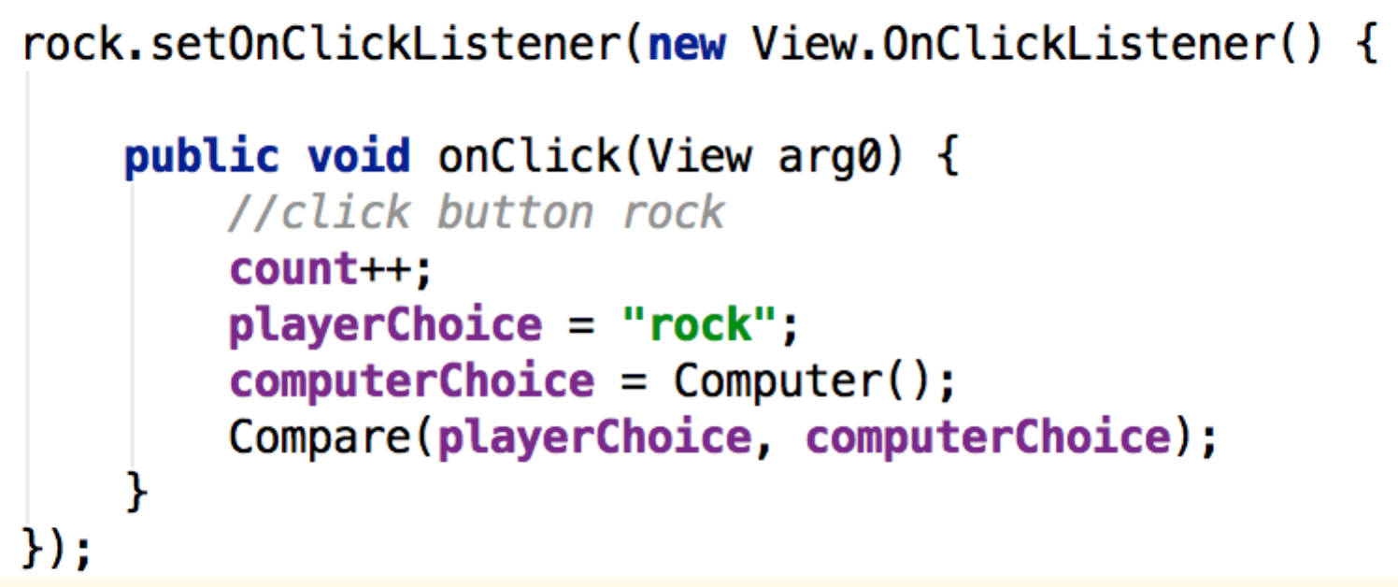
(2) After clicking any button, computer randomly select a choice:
We use the function String Computer() to make the computer randomly select a choice. This function returns a String, which represents the computer’s choice.
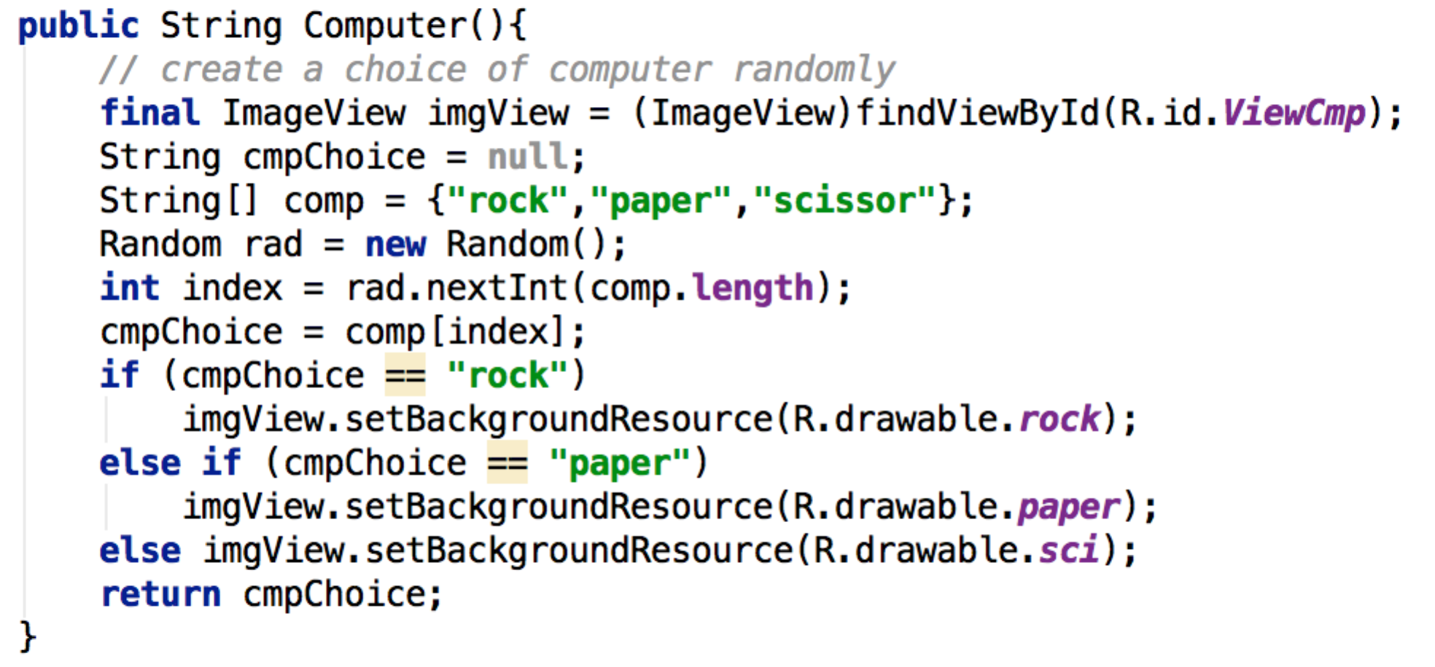
(3) Judge the result.
Instead of using the “switch case” sentence, we choose to write a function String Compare(String s1 String s2) to reduce the redundant code. The inputs are two strings, with the first one implies the player’s choice and the second one implies the computer’s choice. It returns to a string to show the result.
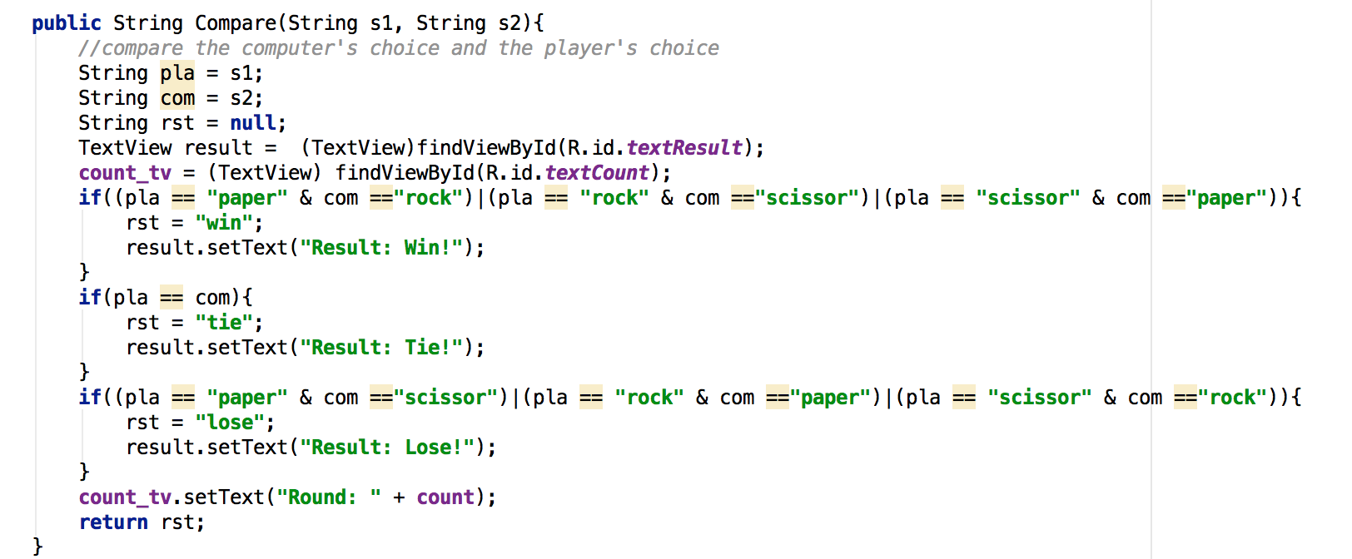

Phase 2 Advanced Design

On the basis of phase one basic design, we added some features to improve the experience of user. Mainly including User Interface improvements and audio enhancements.
1. Action Bar Design
Considering the default action bar style is not to our tastes, we decide to change it into some better-looking one. Because the personal preference of blue, we change the action bar background into blue and the title text color into white. Changes have been made in both “style.xml” file and “Main.java”. In style.xml we customized our own style by adding some new items in the original style. In Main.java we add the ActionBar object, and used “setTitle from Html” method to change the font of the title. It turned out that by using from Html we were able to change the title in many more different styles, including font size, font face and font color. And that’s what we think the more interesting way to do it.

2. TextView Enhancements
Considering the default text font and style not cool enough, we changed the color of the texts all over the screen. Moreover we changed the font of most texts into Monospace, which is the cooler font widely used in Ubuntu Operating systems. And we think that’s not enough, we want the text to glow. So we added the shadow attribute to our textviews and by setting the shadow radius and color we really made our text glowing!

3. Background and Button Image
Since the project require us to design a minigame about elephant, cat and mouse, we began to think what was the better choice about the images. When I was thinking about cat and mouse, it suddenly came to me that the most famous cat and mouse in the world , aren’t they Tom and Jerry? Then I thought it was a fairly good idea to use them. So we changed the button images into an elephant, Tom, and Jerry. They look really funny.
Also we noticed that the background can be changed into something related to the minigame. So we looked over the Internet and chose the one with a white strange robot in the middle of the screen, who is reaching out his hand and is about to gamble. That really corresponds to the theme of our game.
Also, the icon of the app has been changed into a picture with Tom and Jerry smiling.

4. Audio Components
After changing the theme into “Elephant-Tom-Jerry”, we thought it was necessary to add some music to our game to make it even funnier. So we used the theme music of “Tom and Jerry” as the background music. And added button audio effect to each of the button. When clicking “elephant” it will produce the voice of an elephant, when clicking “Jerry” it will play the sound of Jerry etc. Those effects are implemented by adding MediaPlayer Objects in the Main activity and Buttons’ Onclick method, using the resources in our “raw” folder.

5. Probability Calculation
We added the probability calculation in our main.java. So that the user can see his probability of winning the game calculated based on the former games he has played. Someone who is more patient can even use this function to check whether the random numbers produced by java is really RANDOM.

6. Text Buttons
A button named “Reset” has been added so that user can reset the state and begin a new round. It was implemented by making the text clickable in “activity_main.xml “and adding Onclick method to the Textview in “Main.java”. And when it is clicked the data will be set to zero and a text message will be sent to the Result, showing “Round: Reset”.
A button named “Replay” has been added so that when user wants to replay the background music, he can actually replay it. After all it’s the theme music of the famous “Tom and Jerry”, lots of people like that sound.

Conclusion:
By designing this minigame we learnt a lot about the Android Programming. Especially about the understanding of xml files and java files; file system of an Android app; Java functions; App components (activity, intent, service etc.); xml semantics; and connections between xml and java. Also we learnt much about User Interface design. Also learnt how to think like a user when you are designing an app to make it meets the potential users’ need. More importantly, how to use your imagination to surprise your users.

